UNITED STATES
SECURITIES AND EXCHANGE COMMISSION
WASHINGTON, D.C. 20549

FORM 8-K

CURRENT REPORT
Pursuant to Section 13 or 15(d) of the Securities Exchange Act of 1934
Date of Report (Date of earliest event reported): August 25, 2026
Generate Biomedicines, Inc.
(Exact name of Registrant as Specified in Its Charter)

Delaware | 001-43165 | 83-1630228
(State or Other Jurisdiction  of Incorporation) | (Commission File Number) | (IRS Employer  Identification No.)
101 South Street, Suite 900
Somerville, Massachusetts |  | 02143
(Address of Principal Executive Offices) |  | (Zip Code)

Registrant’s Telephone Number, Including Area Code: 888 469-0055

(Former Name or Former Address, if Changed Since Last Report)

Check the appropriate box below if the Form 8-K filing is intended to simultaneously satisfy the filing obligation of the registrant under any of the following provisions:

☐ |  | Written communications pursuant to Rule 425 under the Securities Act (17 CFR 230.425)
☐ |  | Soliciting material pursuant to Rule 14a-12 under the Exchange Act (17 CFR 240.14a-12)
☐ |  | Pre-commencement communications pursuant to Rule 14d-2(b) under the Exchange Act (17 CFR 240.14d-2(b))
☐ |  | Pre-commencement communications pursuant to Rule 13e-4(c) under the Exchange Act (17 CFR 240.13e-4(c))

Securities registered pursuant to Section 12(b) of the Act:

Title of each class |  | Trading  Symbol(s) |  | Name of each exchange on which registered
Common Stock, $0.001 par value per share |  | GENB |  | The Nasdaq Global Select Market
Indicate by check mark whether the registrant is an emerging growth company as defined in Rule 405 of the Securities Act of 1933 (§ 230.405 of this chapter) or Rule 12b-2 of the Securities Exchange Act of 1934 (§ 240.12b-2 of this chapter).
Emerging growth company ☒
If an emerging growth company, indicate by check mark if the registrant has elected not to use the extended transition period for complying with any new or revised financial accounting standards provided pursuant to Section 13(a) of the Exchange Act. ☐

Item 7.01 Regulation FD Disclosure.
On August 25, 2026, draft copies of three posters submitted by Generate Biomedicines, Inc. (the “Company”) and accepted for presentation at the European Respiratory Society Congress 2026 (“ERS”), scheduled for September 5-9, 2026, were inadvertently made publicly available via the ERS website prior to the expiration of the applicable embargo, which the Company believed would run until 6:01 p.m., Eastern time, on September 7, 2026. The draft posters include results of ongoing clinical trials sponsored by the Company and are entitled:
•
“GB-0895, a next-generation anti-TSLP mAb, demonstrates durable pharmacologic activity supporting a single subcutaneous injection every 6 months for asthma patients”;
•
“SOLAIRIA-1 & SOLAIRIA-2: Two Phase 3 randomized, double-blind, placebo-controlled studies of GB-0895, a long-acting anti-TSLP antibody, in severe uncontrolled asthma”; and
•
“GB-0895, a High-Affinity Anti-TSLP Antibody, Demonstrates Potent and Sustained Pharmacological Activity in Adults with COPD.”
As a precautionary measure, the Company is providing the final posters attached hereto as Exhibit 99.1, which include the information that was furnished to ERS.
The information included under Item 7.01 of this Current Report on Form 8-K, including Exhibit 99.1 attached hereto, is intended to be furnished and shall not be deemed "filed" for purposes of Section 18 of the Exchange Act of 1934, as amended (the “Exchange Act”), or otherwise subject to the liabilities of that section, and shall not be deemed incorporated by reference in any filing under the Securities Act of 1933, as amended, or the Exchange Act, except as expressly set forth by specific reference in such filing.
Item 9.01 Financial Statements and Exhibits.
(d) Exhibits.

Exhibit No. |  | Description
99.1 |  | Posters, furnished herewith
104 |  | Cover Page Interactive Data File (embedded within the Inline XBRL document)

SIGNATURES
Pursuant to the requirements of the Securities Exchange Act of 1934, the registrant has duly caused this report to be signed on its behalf by the undersigned hereunto duly authorized.

 |  |  | GENERATE BIOMEDICINES, INC.
Date: | August 25, 2026 | By: | /s/ Jason Silvers
 |  |  | Jason Silvers, President and Chief Financial Officer

Exhibit 99.1

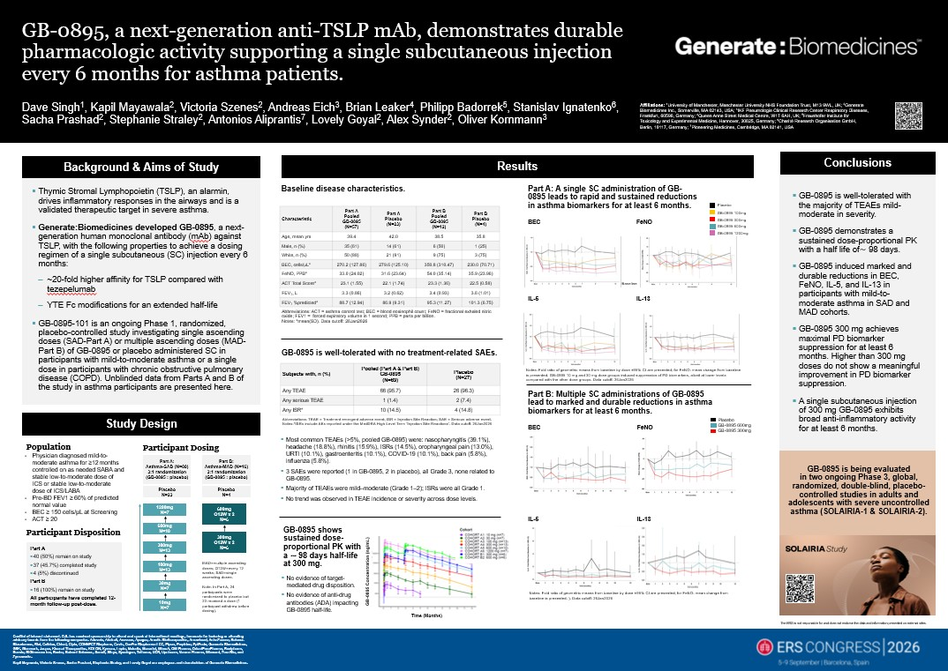

GB-0895, a next-generation anti-TSLP mAb, demonstrates durable pharmacologic activity supporting a single subcutaneous injection every 6 months for asthma patients. Dave Singh1, Kapil Mayawala2, Victoria Szenes2, Andreas Eich3, Brian Leaker4, Philipp Badorrek5, Stanislav Ignatenko6, Sacha Prashad2, Stephanie Straley2, Antonios Aliprantis7, Lovely Goyal2, Alex Synder2, Oliver Kornmann3 Affiliations: 1University of Manchester, Manchester University NHS Foundation Trust, M13 9WL, UK; 2Generate Biomedicines Inc., Somerville, MA 02143, USA; 3IKF Pneumologie Clinical Research Center Respiratory Diseases, Frankfurt, 60596, Germany; 4Queen Anne Street Medical Centre, W1T 6AH, UK; 5Fraunhofer Institute for Toxicology and Experimental Medicine, Hannover, 30625, Germany; 6Charité Research Organisation GmbH, Berlin, 10117, Germany; 7Pioneering Medicines, Cambridge, MA 02141, USA Background & Aims of Study Thymic Stromal Lymphopoietin (TSLP), an alarmin, drives inflammatory responses in the airways and is a validated therapeutic target in severe asthma. Generate:Biomedicines developed GB-0895, a next-generation human monoclonal antibody (mAb) against TSLP, with the following properties to achieve a dosing regimen of a single subcutaneous (SC) injection every 6 months: ~20-fold higher affinity for TSLP compared with tezepelumab YTE Fc modifications for an extended half-life GB-0895-101 is an ongoing Phase 1, randomized, placebo-controlled study investigating single ascending doses (SAD-Part A) or multiple ascending doses (MAD-Part B) of GB-0895 or placebo administered SC in participants with mild-to-moderate asthma or a single dose in participants with chronic obstructive pulmonary disease (COPD). Unblinded data from Parts A and B of the study in asthma participants are presented here. Study Design Population Physician diagnosed mild-to-moderate asthma for ≥12 months controlled on as needed SABA and stable low‐to‐moderate dose of ICS or stable low-to‐moderate dose of ICS/LABA Pre-BD FEV1 ≥ 60% of predicted normal value BEC ≥ 150 cells/μL at Screening ACT ≥ 20 Participant Disposition Part A 40 (50%) remain on study 37 (45.7%) completed study 4 (5%) discontinued Part B 16 (100%) remain on study All participants have completed 12-month follow-up post-dose. Participant Dosing Part A: Asthma-SAD (N=80) 3:1 randomization (GB-0895 : placebo) Placebo N=23 1200mg N=7 600mg N=10 300mg N=13 100mg N=13 30mg N=7 10mg N=7 Part B: Asthma-MAD (N=16) 3:1 randomization (GB-0895 : placebo) Placebo N=4 600mg Q12W x 2 N=6 300mg Q12W x 2 N=6 MAD=multiple ascending doses; Q12W=every 12 weeks; SAD=single ascending doses. Note: In Part A, 24 participants were randomized to placebo but 23 received a dose (1 participant withdrew before dosing). Results Baseline disease characteristics. Characteristic Part A Pooled GB-0895 (N=57) Part A Placebo (N=23) Part B Pooled GB-0895 (N=12) Part B Placebo (N=4) Age, mean yrs 39.4 42.0 38.5 35.8 Male, n (%) 35 (61) 14 (61) 6 (50) 1 (25) White, n (%) 50 (88) 21 (91) 9 (75) 3 (75) BEC, cells/µL* 270.2 (127.86) 279.6 (125.10) 350.8 (310.47) 230.0 (70.71) FeNO, PPB* 33.0 (24.02) 31.6 (23.64) 54.0 (35.14) 35.9 (23.96) ACT Total Score* 23.1 (1.55) 22.1 (1.74) 23.3 (1.36) 22.5 (0.58) FEV₁, L 3.3 (0.86) 3.2 (0.62) 3.4 (0.93) 3.6 (1.01) FEV₁ %predicted* 88.7 (12.94) 86.9 (9.31) 95.3 (11.27) 101.3 (6.75) Abbreviations: ACT = asthma control test; BEC = blood eosinophil count; FeNO = fractional exhaled nitric oxide; FEV1 = forced expiratory volume in 1 second; PPB = parts per billion. Notes: *mean(SD). Data cutoff: 26Jan2026 GB-0895 is well-tolerated with no treatment-related SAEs. Subjects with, n (%) Pooled (Part A & Part B) GB-0895 (N=69) Placebo (N=27) Any TEAE 66 (95.7) 26 (96.3) Any serious TEAE 1 (1.4) 2 (7.4) Any ISR* 10 (14.5) 4 (14.8) Abbreviations: TEAE = Treatment emergent adverse event; ISR = Injection Site Reaction; SAE = Serious adverse event. Notes:*ISRs include AEs reported under the MedDRA High Level Term ‘Injection Site Reactions’. Data cutoff: 26Jan2026 Most common TEAEs (>5%, pooled GB-0895) were: nasopharyngitis (39.1%), headache (18.8%), rhinitis (15.9%), ISRs (14.5%), oropharyngeal pain (13.0%), URTI (10.1%), gastroenteritis (10.1%), COVID-19 (10.1%), back pain (5.8%), influenza (5.8%). 3 SAEs were reported (1 in GB-0895, 2 in placebo), all Grade 3, none related to GB-0895. Majority of TEAEs were mild–moderate (Grade 1–2); ISRs were all Grade 1. No trend was observed in TEAE incidence or severity across dose levels. GB-0895 shows sustained dose-proportional PK with a ⁓ 98 days half-life at 300 mg. No evidence of target-mediated drug disposition. No evidence of anti-drug antibodies (ADA) impacting GB-0895 half-life. Part A: A single SC administration of GB-0895 leads to rapid and sustained reductions in asthma biomarkers for at least 6 months. BEC FeNO IL-5 IL-13 Notes: Fold ratio of geometric means from baseline by dose ±95% CI are presented; for FeNO: mean change from baseline is presented. GB-0895 10 mg and 30 mg dose groups induced suppression of PD biomarkers, albeit at lower levels compared with the other dose groups. Data cutoff: 26Jan2026 Part B: Multiple SC administrations of GB-0895 lead to marked and durable reductions in asthma biomarkers for at least 6 months. BEC FeNO IL-5 IL-13 Notes: Fold ratio of geometric means from baseline by dose ±95% CI are presented; for FeNO: mean change from baseline is presented. ). Data cutoff: 26Jan2026 Placebo GB-0895 100mg GB-0895 300mg GB-0895 600mg GB-0895 1200mg Placebo GB-0895 600mg GB-0895 300mg Conclusions GB-0895 is well-tolerated with the majority of TEAEs mild-moderate in severity. GB-0895 demonstrates a sustained dose-proportional PK with a half life of⁓98 days. GB-0895 induced marked and durable reductions in BEC, FeNO, IL-5, and IL-13 in participants with mild-to-moderate asthma in SAD and MAD cohorts. GB-0895 300 mg achieves maximal PD biomarker suppression for at least 6 months. Higher than 300 mg doses do not show a meaningful improvement in PD biomarker suppression. A single subcutaneous injection of 300 mg GB-0895 exhibits broad anti-inflammatory activity for at least 6 months. GB-0895 is being evaluated in two ongoing Phase 3, global, randomized, double-blind, placebo-controlled studies in adults and adolescents with severe uncontrolled asthma (SOLAIRIA-1 & SOLAIRIA-2). The ERS is not responsible for and does not endorse the data and information presented on external sites. Conflict of Interest statement: D.S. has received sponsorship to attend and speak at international meetings, honoraria for lecturing or attending advisory boards from the following companies: Adovate, Almirall, Anaveon, Apogee, Arcutis Biotherapeutics, Arrowhead, AstraZeneca, Belenos Biosciences, Bial, Celldex, Chiesi, Cipla, CONNECT Biopharm, Covis, DevPro Biopharma LCC, Elpen, Empirico, EpiEndo, Generate Biomedicines, GSK, Glenmark, Jasper, Kinaset Therapeutics, KOLON, Kymera, Lupin, Melodia, Menarini, MicroA, OM Pharma, OrientEuroPharma, Recipharm, Revolo, RIGImmune Inc, Roche, Roivant Sciences, Sanofi, Sitryx, Synairgen, Tetherex, UCB, Upstream, Verona Pharma, Winward, Zura Bio, and Zymeworks. Kapil Mayawala, Victoria Szenes, Sacha Prashad, Stephanie Straley, and Lovely Goyal are employees and shareholders of Generate Biomedicines.

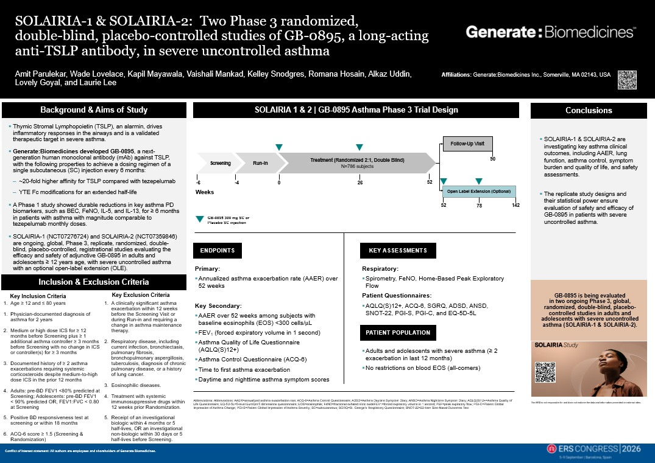

SOLAIRIA-1 & SOLAIRIA-2: Two Phase 3 randomized, double-blind, placebo-controlled studies of GB-0895, a long-acting anti-TSLP antibody, in severe uncontrolled asthma Amit Parulekar, Wade Lovelace, Kapil Mayawala, Vaishali Mankad, Kelley Snodgres, Romana Hosain, Alkaz Uddin, Lovely Goyal, and Laurie Lee Affiliations: Generate:Biomedicines Inc., Somerville, MA 02143, USA Background & Aims of Study Thymic Stromal Lymphopoietin (TSLP), an alarmin, drives inflammatory responses in the airways and is a validated therapeutic target in severe asthma. Generate:Biomedicines developed GB-0895, a next-generation human monoclonal antibody (mAb) against TSLP, with the following properties to achieve a dosing regimen of a single subcutaneous (SC) injection every 6 months: ~20-fold higher affinity for TSLP compared with tezepelumab YTE Fc modifications for an extended half-life A Phase 1 study showed durable reductions in key asthma PD biomarkers, such as BEC, FeNO, IL-5, and IL-13, for ≥ 6 months in patients with asthma with magnitude comparable to tezepelumab monthly doses. SOLAIRIA-1 (NCT07276724) and SOLAIRIA-2 (NCT07359846) are ongoing, global, Phase 3, replicate, randomized, double-blind, placebo-controlled, registrational studies evaluating the efficacy and safety of adjunctive GB-0895 in adults and adolescents ≥ 12 years age, with severe uncontrolled asthma with an optional open-label extension (OLE). Inclusion & Exclusion Criteria Key Inclusion Criteria 1 Age ≥ 12 and ≤ 80 years 1 Physician-documented diagnosis of asthma for 2 years 2 Medium or high dose ICS for ≥ 12 months before Screening plus ≥ 1 additional asthma controller ≥ 3 months before Screening with no change in ICS or controller(s) for ≥ 3 months 3 Documented history of ≥ 2 asthma exacerbations requiring systemic corticosteroids despite medium-to-high dose ICS in the prior 12 months 4 Adults: pre-BD FEV1 <80% predicted at Screening; Adolescents: pre-BD FEV1 < 90% predicted OR, FEV1:FVC < 0.80 at Screening 5 Positive BD responsiveness test at screening or within 18 months 6 ACQ-6 score ≥ 1.5 (Screening & Randomization) Key Exclusion Criteria 1 A clinically significant asthma exacerbation within 12 weeks before the Screening Visit or during Run-in and requiring a change in asthma maintenance therapy. 2 Respiratory disease, including current infection, bronchiectasis, pulmonary fibrosis, bronchopulmonary aspergillosis, tuberculosis, diagnosis of chronic pulmonary disease, or a history of lung cancer. 3 Eosinophilic diseases. 4 Treatment with systemic immunosuppressive drugs within 12 weeks prior Randomization. 5 Receipt of an investigational biologic within 4 months or 5 half-lives, OR an investigational non-biologic within 30 days or 5 half-lives before Screening. SOLAIRIA 1 & 2 | GB-0895 Asthma Phase 3 Trial Design Screening Run-In Treatment (Randomized 2:1, Double Blind) N=786 subjects Weeks Follow-Up Visit Open Label Extension (Optional) -6 -4 0 26 52 90 52 78 142 ENDPOINTS Primary: Annualized asthma exacerbation rate (AAER) over 52 weeks Key Secondary: AAER over 52 weeks among subjects with baseline eosinophils (EOS) <300 cells/L FEV1 (forced expiratory volume in 1 second) Asthma Quality of Life Questionnaire (AQLQ(S)12+) Asthma Control Questionnaire (ACQ-6) Time to first asthma exacerbation Daytime and nighttime asthma symptom scores KEY ASSESSMENTS Respiratory: Spirometry, FeNO, Home-Based Peak Exploratory Flow Patient Questionnaires: AQLQ(S)12+, ACQ-6, SGRQ, ADSD, ANSD, SNOT-22, PGI-S, PGI-C, and EQ-5D-5L PATIENT POPULATION Adults and adolescents with severe asthma (≥ 2 exacerbation in last 12 months) No restrictions on blood EOS (all-comers) Conclusions SOLAIRIA-1 & SOLAIRIA-2 are investigating key asthma clinical outcomes, including AAER, lung function, asthma control, symptom burden and quality of life, and safety assessments. The replicate study designs and their statistical power ensure evaluation of safety and efficacy of GB-0895 in patients with severe uncontrolled asthma. GB-0895 is being evaluated in two ongoing Phase 3, global, randomized, double-blind, placebo-controlled studies in adults and adolescents with severe uncontrolled asthma (SOLAIRIA-1 & SOLAIRIA-2). The ERS is not responsible for and does not endorse the data and information presented on external sites. Abbreviations: Abbreviations: AAER=annualized asthma exacerbation rate; ACQ-6=Asthma Control Questionnaire; ADSD=Asthma Daytime Symptom Diary; ANSD=Asthma Nighttime Symptom Diary; AQLQ(S)12+=Asthma Quality of Life Questionnaire; EQ-5D-5L=5-level EuroQol 5 dimensions questionnaire; EOS=eosinophils; FeNO=fractional exhaled nitric oxideFEV1=forced expiratory volume in 1 second; PEF=peak expiratory flow; PGI-C=Patient Global Impression of Asthma Change; PGI-S=Patient Global Impression of Asthma Severity; SC=subcutaneous; SGRQ=St. George's Respiratory Questionnaire; SNOT-22=22-Item Sino-Nasal Outcomes Test Conflict of Interest statement: All authors are employees and shareholders of Generate Biomedicines.

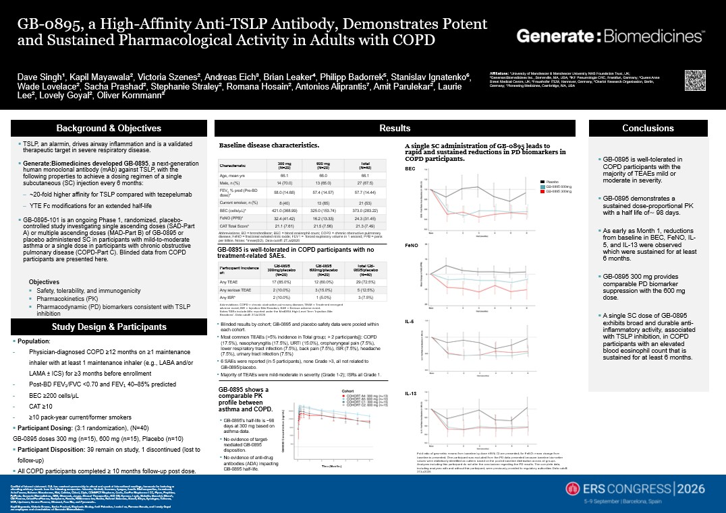

GB-0895, a High-Affinity Anti-TSLP Antibody, Demonstrates Potent and Sustained Pharmacological Activity in Adults with COPD Dave Singh¹, Kapil Mayawala², Victoria Szenes², Andreas Eich³, Brian Leaker⁴, Philipp Badorrek⁵, Stanislav Ignatenko⁶, Wade Lovelace², Sacha Prashad², Stephanie Straley², Romana Hosain², Antonios Aliprantis⁷, Amit Parulekar², Laurie Lee², Lovely Goyal², Oliver Kornmann³ Affiliations: ¹University of Manchester & Manchester University NHS Foundation Trust, UK; ²Generate:Biomedicines Inc., Somerville, MA, USA; ³IKF Pneumologie CRC, Frankfurt, Germany; ⁴Queen Anne Street Medical Centre, UK; ⁵Fraunhofer ITEM, Hannover, Germany; ⁶Charité Research Organisation, Berlin, Germany; ⁷Pioneering Medicines, Cambridge, MA, USA Background & Objectives TSLP, an alarmin, drives airway inflammation and is a validated therapeutic target in severe respiratory disease. Generate:Biomedicines developed GB-0895, a next-generation human monoclonal antibody (mAb) against TSLP, with the following properties to achieve a dosing regimen of a single subcutaneous (SC) injection every 6 months: ~20-fold higher affinity for TSLP compared with tezepelumab YTE Fc modifications for an extended half-life GB-0895-101 is an ongoing Phase 1, randomized, placebo-controlled study investigating single ascending doses (SAD-Part A) or multiple ascending doses (MAD-Part B) of GB-0895 or placebo administered SC in participants with mild-to-moderate asthma or a single dose in participants with chronic obstructive pulmonary disease (COPD-Part C). Blinded data from COPD participants are presented here. Objectives Safety, tolerability, and immunogenicity Pharmacokinetics (PK) Pharmacodynamic (PD) biomarkers consistent with TSLP inhibition Study Design & Participants Population: Physician-diagnosed COPD ≥12 months on ≥1 maintenance inhaler with at least 1 maintenance inhaler (e.g., LABA and/or LAMA ± ICS) for ≥3 months before enrollment Post-BD FEV₁/FVC <0.70 and FEV₁ 40–85% predicted BEC ≥200 cells/µL CAT ≥10 ≥10 pack-year current/former smokers Participant Dosing: (3:1 randomization), (N=40) GB-0895 doses 300 mg (n=15), 600 mg (n=15), Placebo (n=10) Participant Disposition: 39 remain on study, 1 discontinued (lost to follow-up) All COPD participants completed ≥ 10 months follow-up post dose. Baseline disease characteristics. Abbreviations: BD = bronchodilator; BEC = blood eosinophil count; COPD = chronic obstructive pulmonary disease; FeNO = fractional exhaled nitric oxide; FEV1 = forced expiratory volume in 1 second; PPB = parts per billion. Notes: *mean(SD). Data cutoff: 27Jul2026 GB-0895 is well-tolerated in COPD participants with no treatment-related SAEs. Participant Incidence of: GB-0895 300mg/placebo (N=20) GB-0895 600mg/placebo (N=20) Total GB-0895/placebo (N=40) Any TEAE 17 (85.0%) 12 (60.0%) 29 (72.5%) Any serious TEAE 2 (10.0%) 3 (15.0%) 5 (12.5%) Any ISR* 2 (10.0%) 1 (5.0%) 3 (7.5%) Abbreviations: COPD = chronic obstructive pulmonary disease; TEAE = Treatment emergent adverse event; ISR = Injection Site Reaction; SAE = Serious adverse event. Notes:*ISRs include AEs reported under the MedDRA High Level Term ‘Injection Site Reactions’. Data cutoff: 27Jul2026 Blinded results by cohort; GB-0895 and placebo safety data were pooled within each cohort. Most common TEAEs (>5% incidence in Total group; > 2 participants]): COPD (17.5%), nasopharyngitis (17.5%), URTI (15.0%), oropharyngeal pain (7.5%), lower respiratory tract infection (7.5%), back pain (7.5%), ISR (7.5%), headache (7.5%), urinary tract infection (7.5%) 6 SAEs were reported (in 5 participants), none Grade >3, all not related to GB-0895/placebo. Majority of TEAEs were mild-moderate in severity (Grade 1-2); ISRs all Grade 1. GB-0895 shows a comparable PK profile between asthma and COPD. GB-0895's half-life is ~98 days at 300 mg based on asthma data. No evidence of target-mediated GB-0895 disposition. No evidence of anti-drug antibodies (ADA) impacting GB-0895 half-life. Time (Months) A single SC administration of GB-0895 leads to rapid and sustained reductions in PD biomarkers in COPD participants. BEC FeNO IL-5 IL-13 Placebo GB-0895 600mg GB-0895 300mg Fold ratio of geometric means from baseline by dose ±95% CI are presented; for FeNO: mean change from baseline is presented. One participant was excluded from the PD data presented because baseline biomarker values were statistically identified as outliers based on the pooled baseline distribution across all groups. Analyses including this participant do not alter the conclusions regarding the PD results. The complete data, including analyses with and without this participant, were previously provided to regulatory authorities Data cutoff: 27Jul2026 Conclusions GB-0895 is well-tolerated in COPD participants with the majority of TEAEs mild or moderate in severity. GB-0895 demonstrates a sustained dose-proportional PK with a half life of⁓ 98 days. As early as Month 1, reductions from baseline in BEC, FeNO, IL-5, and IL-13 were observed which were sustained for at least 6 months. GB-0895 300 mg provides comparable PD biomarker suppression with the 600 mg dose. A single SC dose of GB-0895 exhibits broad and durable anti-inflammatory activity, associated with TSLP inhibition, in COPD participants with an elevated blood eosinophil count that is sustained for at least 6 months. Conflict of Interest statement: D.S. has received sponsorship to attend and speak at international meetings, honoraria for lecturing or attending advisory boards from the following companies: Adovate, Almirall, Anaveon, Apogee, Arcutis Biotherapeutics, Arrowhead, AstraZeneca, Belenos Biosciences, Bial, Celldex, Chiesi, Cipla, CONNECT Biopharm, Covis, DevPro Biopharma LCC, Elpen, Empirico, EpiEndo, Generate Biomedicines, GSK, Glenmark, Jasper, Kinaset Therapeutics, KOLON, Kymera, Lupin, Melodia, Menarini, MicroA, OM Pharma, OrientEuroPharma, Recipharm, Revolo, RIGImmune Inc, Roche, Roivant Sciences, Sanofi, Sitryx, Synairgen, Tetherex, UCB, Upstream, Verona Pharma, Winward, Zura Bio, and Zymeworks. Kapil Mayawala, Victoria Szenes, Sacha Prashad, Stephanie Straley, Amit Palurekar, Laurie Lee, Romana Hosein, and Lovely Goyal are employees and shareholders of Generate Biomedicines.

